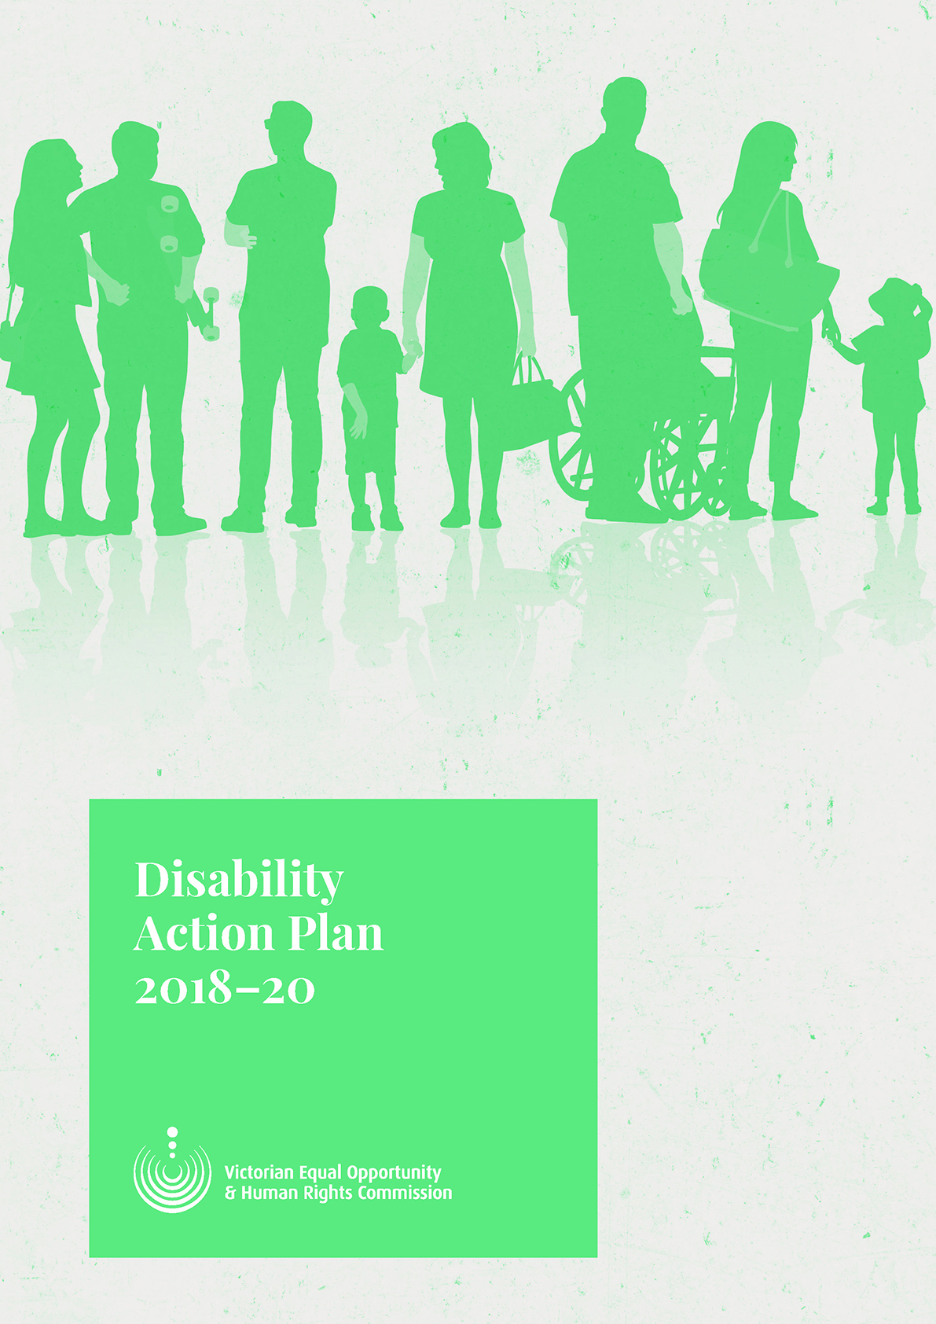
f

Disability Action Plan 2018-2020




humanrightscommission.vic.gov.au

humanrightscommission.vic.gov.au

humanrightscommission.vic.gov.au

humanrightscommission.vic.gov.au
Disability
Action Plan
2018-20


Published by the Victorian Equal Opportunity and Human Rights Commission (the Commission), Level 3, 204 Lygon Street, Carlton, Victoria 3053, November 2018.
Contact us
Enquiry Line 1300 292 153 or (03) 9032 3583
Fax 1300 891 858
Hearing impaired (TTY) 1300 289 621
Interpreters 1300 152 494
Email enquiries@veohrc.vic.gov.au
Website humanrightscommission.vic.gov.au
Acknowledgement
The Commission respectfully acknowledges and celebrates the Traditional Owners of the lands throughout Victoria and pays its respects to their Elders, children and youth of past, current and future generations.
Thank you
The Commission thanks the Disability Reference Group, Office for Disability, Office of the Public Advocate and Commission staff for their assistance developing this plan.
Copyright
Copyright © State of Victoria 2018. This Disability Action Plan 2018-2020 is provided under a Creative Commons Attribution 4.0 licence. This means you can re-use it, as long as you credit the Commission and comply with the other license terms.

Contents
Disability Action Plan 2018-2020 1
Contents 3
Background 4
About us 4
Our vision 4
About this plan 4
Context 4
Law and policy 4
What do we mean by disability? 5
What we want to achieve and why 5
Our services 5
Our staff 5
Making change 6
Working together 6
Being accountable 6
Our actions 7

Background

About us
The Commission is a Victorian independent statutory body responsible for addressing human rights issues and discrimination. To do this we:
- inform and educate people about their rights and responsibilities
- help people resolve disputes about discrimination, sexual harassment, victimisation, and racial and religious vilification
- undertake voluntary reviews of programs and practices to help people and organisations comply with the law
- undertake research to identify, understand and find solutions to systemic causes of discrimination and human rights breaches
- conduct investigations to identify and eliminate systemic discrimination
- intervene in court and tribunal proceedings that involve equal opportunity and human rights issues.
We have responsibilities under three laws:
- Equal Opportunity Act 2010
- Racial and Religious Tolerance Act 2001
- Charter of Human Rights and Responsibilities Act 2006.

Our vision
Our vision is for a fair, safe and inclusive Victoria where every person is respected and treated with dignity. Our mission is to engage and influence law and policy makers, institutions, communities and individuals to protect and promote human rights in Victoria.
More information about our vision and plan to achieve it is in our 2017–22 Strategic Plan, Upholding human rights close to home.

About this plan
To achieve our vision we must be accessible to and inclusive of people with disabilities, and use our role to bring about improvements for people with disabilities throughout Victoria.
This plan sets out how we plan to do this. It documents our commitments to people with disabilities over the next two years. It is designed to drive practical actions to make our work more inclusive, accessible and informed by a disability perspective.

Context

Law and policy
The Victorian Disability Act 2006 contains the legal requirements for disability action plans in Victoria. We have also considered the:
- Disability Discrimination Act 1992 (Cth)
- Charter of Rights and Responsibilities 2006
- Equal Opportunity Act 2010
- United Nations International Convention on the Rights of Persons with Disabilities
- Victorian state disability action plan, Absolutely Everyone and economic participation plan, Every Opportunity.
We have also considered disability action plans from other organisations, including the Australian Human Rights Commission, Office of the Public Advocate, Department of Health and Human Services and Victorian Ombudsman.

What do we mean by disability?
We take a broad approach to disability, informed by the United Nations International Convention on the Rights of Persons with Disabilities. This recognises disability is an evolving concept and arises from barriers in attitudes and the environment.
We know that disabilities can be:
- physical, sensory and intellectual, work-related injuries, medical conditions, mental, psychological, learning disabilities, or a combination of more than one
- visible or invisible, there from birth or acquired over time, and ongoing or fluctuating
People with disabilities are diverse. Some will experience additional unfair treatment as a result of, for example, racism, misogyny, ageism, homophobia or transphobia.

What we want to achieve and why
This plan is based around five themes:
- our services
- our staff
- making changes
- working together
- being accountable

Our services
Objective: our premises and services are accessible to, and used by, people with disabilities.
Why we are doing this
Over the past few years we have made our premises and services more accessible. This has included getting and keeping accreditation for communication accessibility and improving the physical accessibility of our office. We want to maintain and build on these improvements.

Our staff
Objective: increase the proportion of staff with a disability and ensure they have the resources they need to do their job.
Why we are doing this
We want to reflect the community we serve. This includes attracting and retaining staff with disabilities and giving people the support they need to do their job.

Making change
Objective: use our functions to improve outcomes for people in Victoria with disabilities
Why we are doing this
The Commission’s core work is to combat discrimination and raise awareness of human rights. This includes addressing discrimination based on disability. We want to ensure that when we decide what work to do, how to do it, and communicate about it, we are listening to what people with disabilities in Victoria need.

Working together
Objective: work respectfully and effectively with each other and with key stakeholders and learn from experts, particularly those with lived experience of disability.
Why we are doing this
We cannot and should not try to achieve change alone. As part of our principles of leading with evidence and creating enduring change, we want to ensure we listen to and work with the right people. This particularly includes organisations run by and for people with lived experience of disability. We also want to ensure we share our information, expertise and time with other organisations and with each other.

Being accountable
Objective: this plan is a living document which is actively used by Commission leadership, and it is easy for staff and stakeholders to track our progress.
Why we are doing this
In accordance with our value of accountability and principle of being the best we can be, we want to ensure this plan is embedded in our daily work and we are easily held to account for how well we have done this.

Our actions
Objective 1: Our premises and services are accessible to, and used by, people with disabilities
Outcome | Action | Measure | Time frame | Responsibility
1.1 Our premises and communications channels are accessible and identified as such | Maintain accessibility standards and accreditations in relation to our external service delivery. Ensure staff regularly participate in disability awareness and communication training  Arrange accessibility audits at least every other year and action recommendations within the Commission’s influence and control  Share recommendations that relate to areas outside the Commission’s control with relevant decision-makers (e.g. building owners) and advocate for their implementation. Consult with co-tenants Office of the Public Advocate to determine any joint areas of interest  Establish a tool to survey visitors to our premises on accessibility  Consider whether any additional resources or mechanisms are a required to enable the Commission to support neurodiverse users of our services | Accreditation maintained  Training completed  Recommended improvements implemented  The people we work with and provide services for report increased satisfaction with our accessibility. | Ongoing | Head of Business Services
1.2 Our publications and information about our services are accessible and respectful of people with disabilities | Ensure all core publications are available in multiple accessible formats (e.g. Easy English, Auslan) and plain language | Publications available and reflect current best practice on accessible and preferred terminology. | Ongoing | Head of Communications and Campaigns  Support from all branch Heads to model and enforce generation of accessible formats and style guide
1.3 Accessibility is built into the Commission’s digital communication strategy | Ensure accessibility is a core commitment in the Department’s digital strategy. Consult with the Disability Reference Group on the digital strategy. | Strategy created with commitment to accessibility  Strategy reflects Web Content Accessibility Guidelines (WCAG) 2.1. | December 2018 | Executive Director
1.4 Staff are provided support to produce accessible and plain language materials | Develop internal guidelines for staff on creating accessible and plain language documents.  Review style guides every 12 months to ensure guidance on accessibility and terminology is current  Information about plain language training to be available to all staff | Guidelines and training available | December 2018 | Head of Communications and Campaigns  Support from all branch Heads to model and enforce use of internal guidelines  Support from Head of Business Services to include reference to plain language training in Learning and Development Framework
1.5 Improve access to services for people with cognitive impairments and intellectual disabilities | Identify and report to Leadership Team on the proportion of new clients of dispute resolution and enquiry services who disclose an intellectual disability or cognitive impairment  Survey users of dispute resolution service for any feedback for improving accessibility of the service and consider all any recommendations | Proportion of new enquiries or disputes raised by people with intellectual disability remains level or increases | Ongoing | Head of Legal and Dispute Resolution  Support from Education and Engagement
1.6 Our events, including education and engagement events, are accessible | Ensure events are produced in a format which are physically accessible and include Auslan interpreters | Surveys of event attendees report accessibility needs met | Ongoing | Head of Communications and Campaigns  Support from Education and Engagement
1.7 We are compliant with current and new legal developments in accessibility and inclusion | Monitor any legal developments affecting accessibility and make recommendations on any action required of the Commission to relevant internal decision-maker | Commission’s policies and practice reflect current law | Ongoing | Head of Legal and Dispute Resolution  Support from Head of Business Services
1.8 Information about the outcomes of any legal cases in which the Commission is involved in is available in accessible formats, especially those relating to disability rights | Establish a process for developing accessible and effective communication tools to inform people with disabilities about the outcomes of cases, including information on any practical implications for people with disabilities on what the cases mean for them and any actions they can take as a result | Information about all cases available in accessible formats | Ongoing | Head of Legal and Dispute Resolution  Support from Head of Communications and Campaigns
Objective 2: increase the proportion of staff with a disability and ensure they have the resources they need to do their job.
Outcome | Action | Measure | Time frame | Responsibility
2.1 Recruitment, on-boarding and retention strategies and processes represent best practice to attract and retain a diverse workforce, including people with disabilities | Develop a structured internship program in partnership with tertiary education institutions that attracts and develops diverse student populations who reflect Victoria’s diversity, including students with disabilities.  Review and develop position descriptions to attract more diverse candidates with more diverse experience.  Showcase workplace policies and commitments that support diversity and inclusion  Identify sourcing methods that include more diverse candidates, including agencies and support services that work with people with disabilities or other under-represented groups  Review recruitment and retention policies, strategies and processes to ensure they are in accordance with accessibility best practice.  Continue to provide unconscious bias training for all employees, including specific training on bias in recruitment for managers.  Consider whether any additional resources or mechanisms are required to enable the Commission to support neurodiverse staff  Ensure accessibility is built into tender and procurement requirements for any new information and communications technology tools | This action will be assessed through the Commission’s annual Diversity and Inclusion Survey, the annual People Matters survey and exit interviews. This will include looking at:  - Whether proportion of employees who report they have a disability has increased  - All employees who report they have a disability report they are able to engage fully in the working and social life of the Commission  - Increased number of employees with a disability who disclose their disability  - VPS level of respondents | December 2020 | Head of Business Services
2.2 Managers are well equipped to support staff with disabilities | Include specific training for managers to support staff with disabilities in Commission’s Learning and Development Framework. Investigate using training provided by disability organisations for this purpose. | As above | December 2020 | Head of Business Services  Support from all managers to take training and implement learning
2.3 Commission staff are equipped with knowledge to self-advocate and to support colleagues and clients with disabilities | Provide mandatory training for staff on disability awareness and communication accessibility at least every two years. Investigate using training provided by disability organisations for this purpose. This requirement to be reflected in Commission’s Learning and Development Framework. | As above | Ongoing | Head of Business Services
2.4 People with disabilities are aware of and encouraged to apply for vacant positions at the Commission | Circulate job advertisements for Commission vacancies to the Disability Reference Group for circulation through members’ networks | As above | Ongoing | Head of Policy and Research  Support from Business Services
2.5 Internal policies and processes are produced in an accessible format | Add accessibility requirement template for new policies and communicate to staff | Sample of core policies shows they are available in accessible formats | December 2019 | Head of Business Services  Support from branch Heads with policy ownership responsibilities

Objective 3: Use our functions to improve outcomes for people in Victoria with disabilities
Outcome | Action | Measure | Time frame | Responsibility
3.1 People with disabilities in Victoria are aware their legal rights and how to access the Commission’s complaints services | Provide at least two education sessions each year to disability advocates on disability and intersectional discrimination, reasonable adjustments and making complaints to the Commission. Ensure at least one of these reaches advocates who assist people with intellectual disability or cognitive impairments. | Increase in inquiries and complaints by disability advocates. | Ongoing | Head of Education and Engagement  Support from Head of Legal and Dispute Resolution
3.2 Provide tools to assist people with disabilities to discuss their rights in the workplace | Pilot a training program with two disability representative groups (including one where the disability may be invisible) focusing on holding conversations relating to reasonable adjustments in the workplace with employers.  Use the sessions to prepare a “how-to” information guides for employees to have sensitive conversations around specific disability and adjustments with employers. Consider the pilot for other disability representative groups. | Members of the disability representative groups surveyed after 6 months report increased empowerment in the workplace. | December 2020 | Head of Education and Engagement
3.3 Ensure all research informed by a disability perspective | Develop a framework for what disability representation could require for each research project, with that representation decided early on during project scoping.  Testing of the framework to see if it can be applied to all Commission research projects. | Process developed and implemented to ensure this framework is embedded in all research project planning | December 2019 | Head of Policy and Research
Objective 4: Work respectfully and effectively with each other and key stakeholders and learn from experts, particularly those with lived experience of disability
Outcome | Action | Measure | Time frame | Responsibility
4.1 Our business planning is informed by a disability perspective | Meetings of the Disability Reference Group contribute to the Commission’s strategic priorities and provide input on key Commission strategic documents | Meetings of the Disability Reference Group organised around the Commission’s strategic priorities  Commission’s key strategic documents informed by input of Disability Reference Group | Ongoing | Head of Policy and Research  Support from Head of Business Services
4.2 Knowledge and feedback from Disability Reference Group is maximised and shared with Commission staff | Annual survey created for members of Disability Reference Group to provide feedback on recommended improvements for Commission. Feedback collated and provided to Leadership Team.  Process established to share themes and feedback from each meeting of Disability reference Group with Commission staff | Survey results provided to Leadership Team  All staff have access to feedback, suggestions and themes from Disability Reference Group | Ongoing | Head of Policy and Research
4.3 Commission staff are informed of developments in disability and discrimination law | Maintain membership of Law Institute of Victoria Discrimination Law Committee and Disability Law Committee and ensure representatives share information and materials with all staff  All memberships recorded in Commission’s Record all collaborations in Commission’s database of working, reference and advisory groups | All staff can access information about these networks and materials relating to them | Ongoing | Head of Legal and Dispute Resolution  Head of Education and Engagement
4.4 Commission staff are informed of developments in disability and discrimination research | Establish and maintain effective collaborations with peak disability research groups  Record all collaborations in Commission’s database of working, reference and advisory groups  Continue to participate in the Victoria Police Disability Portfolio Reference Group | Commission has contacts and information exchange with peak research groups  Information from any regular group membership regularly shared with Commission leadership and available to all staff | Ongoing | Head of Policy and Research

Objective 5: this plan is a living document which is actively used by Commission leadership, and it is easy for staff and stakeholders to track our progress.
Outcome | Action | Measure | Time frame | Responsibility
5.1 Be transparent about the plan and our progress | Publicly report against this plan in our annual report and on our website  Share a copy of the plan with the Australian Human Rights Commission, which can collect plans from all Australian organisations | Plan and information about progress available in accessible format, with progress updated at least annually  Copy of plan available on website of Australian Human Rights Commission | Ongoing | Head of Business Services  With support from Campaigns and Communication
5.2 Be accountable for progress | All Commission Leadership Team are accountable for their commitments in this plan in annual performance development processes | Professional development plans include reference to this plan | Ongoing | Executive
5.3 Keep the plan alive | Reflect on this plan and actions to assist people with disabilities in annual business planning process | Business planning process includes references to actions to gain improvements for people with disabilities in Victoria | Ongoing | Executive

Contact us
Enquiry Line 1300 292 153 or (03) 9032 3583
Fax 1300 891 858
Hearing impaired (TTY) 1300 289 621
Interpreters 1300 152 494
Email information@veohrc.vic.gov.au
Website www.humanrightscommission.vic.gov.au
Follow us on Twitter www.twitter.com/VEOHRC
Find us at www.facebook.com/VEOHRC

humanrightscommission.vic.gov.au

