Pay equality toolkit:
Staff poster template
This template will help you to create a poster for staff details the steps of your equal pay complaints procedure. Tailor it to suit your business. Read the instructions below to create your own poster and delete this page from your final version.
Instructions:
- Where you see <Business name> replace it with your business’s legal trading name. The quickest way to do this is to use the Edit > Replace function.
- Throughout this template there are guidance notes to help you complete the details of your procedure. There are indicated in yellow text like this: [Guidance note:] When you have read the information and completed the actions, select and delete the yellow text. Guidance notes are not intended to be part of your final version.
- Once you have finished work on this poster, delete this instruction page.
- You may wish to add your logo and print your poster on A3 paper to display in an employee’s work area.
Need more information?
Take a look at our equal pay research and education resources.
Note: delete this page once you complete this poster.

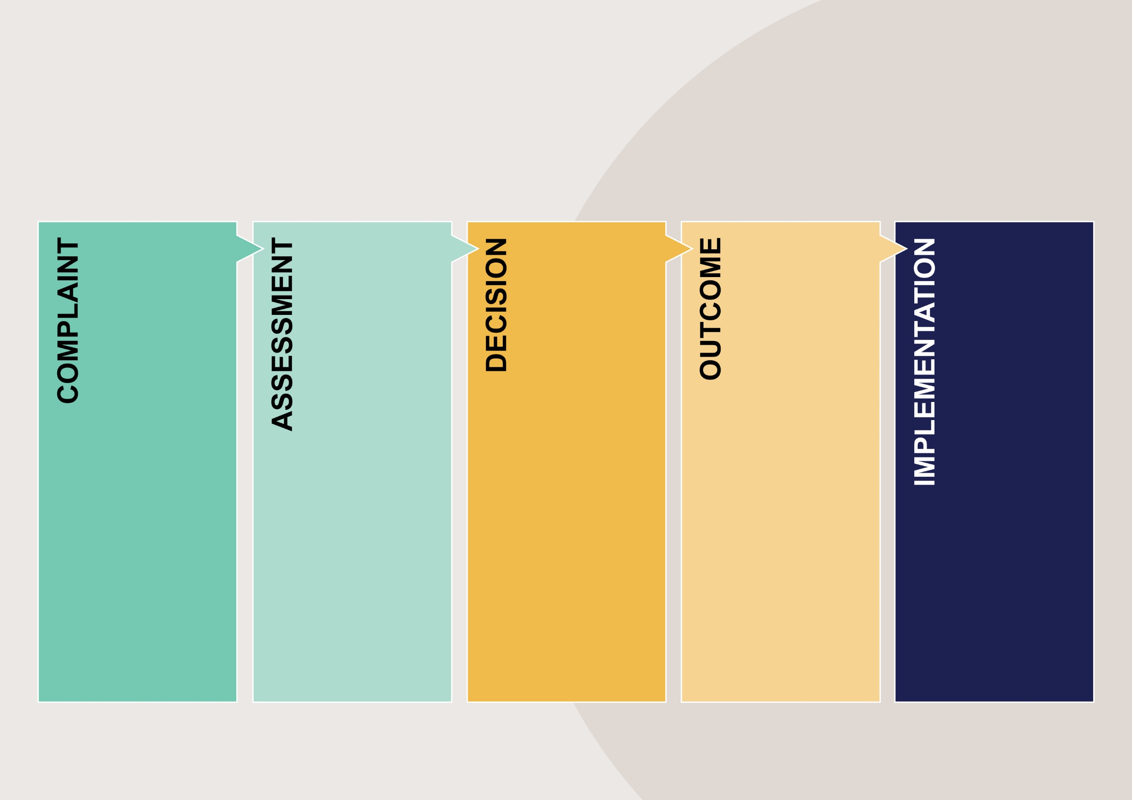
All employees in Victoria have the right to make a complaint to the Fair Work Ombudsman. If the pay issue is a result of discrimination, employees can make a complaint to the Victorian Equal Opportunity and Human Rights Commission.
What to do if you have a pay equality issue
at <Business name>

<Business name> commits to following the steps identified to resolve the complaint within the designated time frame and invites you to provide feedback on your experience. [Guidance note: explain how the complainant can provide feedback].
When a formal decision regarding the complaint is made, the outcome will be communicated to you and any other involved parties. The decision will include the steps to be taken to rectify the pay equality issue.
You will be informed of the results of the investigation and a proposed resolution.
If you do not agree with the results or resolution, you can make an appeal by contacting [Guidance note: Explain who they should contact to begin the appeal process.]
Your complaint is investigated to confirm a pay equality issue and recommended actions. Relevant information and documents that could help assess the pay equality issue will be gathered.
They may also conduct interviews with you, your supervisor, and other relevant parties with your consent.
You can make a complaint about a pay issue by … [Guidance note: detail how your employees can make a complaint.]
You will receive an email acknowledging your complaint and containing information about what the next steps will be and how long it is likely to take.
[Guidance note: Put a statement of why complaints about pay equality is important to your business. This can be taken from your pay equality complaints procedure.] This procedure is designed to protect employees who make pay equality complaints. You will be respected and supported in making a pay equality complaint – please inform us if this is not your experience.

