DATA REPORT 2022–23
Understanding the discrimination experienced by First Nations people

Accurate data about the experiences of First Nations people is critical for ensuring policy decisions and public services meet the needs of First Nations communities. We’ve been working to improve the data we collect from our enquiries and complaints services and how we can share it with other organisations serving First Nations people.
Under our First Nations Data Strategy, we are committed to prioritising privacy and consent, respecting self-determination and data sovereignty, supporting cultural rights, and ensuring transparency and accountability.
We acknowledge that the complaints and enquiries we have received represent just a fraction of the instances of discrimination experienced by First Nations people.
This data should not be seen or published as definitive. It is not representative of all experiences of discrimination experienced by First Nations people.
Even when people know about our services, there are many barriers that may deter them from reporting what has happened to them. This includes the mistrust of government services and systems, because of past government policies, including segregation, displacement, and separation of families. This mistrust is also from a history of poor complaint handling across public services and genuine fear that making a complaint will result in retribution.
In recent years we have made changes to ensure our processes are culturally appropriate for First Nations people. It will take time and ongoing improvements to our services to ensure First Nations people continue to come to us to report their experiences.
We also acknowledge that there are some limitations in the data we have available. While our complaints team started recording whether someone identified themselves as a First Nations person in 2017–18, we only started asking this question explicitly in 2019–20. Our previous approach was to minimise the mandatory questions we ask, but we recognise that providing a culturally safe way for people to identify as a First Nations person is important for collecting data and ensuring our service responds to their needs.
We’ll be publishing this data report each year and providing it directly to our key First Nations stakeholders in the hope that it can identify emerging issues for First Nations communities and continue to shape effective policies and services.

Key findings
- 157 First Nations people have made complaints to the Commission since 2017–18.
- We’ve received 187 enquiries from First Nations people, raising 329 issues of discrimination.
- Racism and disability discrimination were the most common types of discrimination in the complaints and enquiries we received.
- The most common places where First Nations people experienced discrimination were in provision of goods and services and at work.
- Discrimination against First Nations people often occurred in interactions with retail businesses, real estate companies, health and medical providers and state government agencies.
- Almost two-thirds of First Nations complainants (62%) were women.
About our complaints data
When a person makes a complaint about discrimination, we record some key details including:
- what type of discrimination the person experienced – for example, discrimination based on race, sex, disability, age or sexual orientation (these characteristics are known as protected attributes)
- where the discrimination occurred – for example, in employment, in education or in the provision of goods and services (these places are known as areas of public life).
A single complaint can include more than one type of discrimination.
About our complaints process
We can help resolve complaints under two Victorian laws: the Equal Opportunity Act 2010 and the Racial and Religious Tolerance Act 2001.
Under these laws, anyone (of any age – usually those under 18 are supported by a parent or carer) can make a complaint if they believe they have experienced discrimination, sexual harassment, racial or religious vilification or victimisation.
Complaints are normally about individual experiences. We can also accept representative complaints which are issues affecting a lot of people, but these are less common. Generally, we may receive up to two of these a year but are yet to receive any representative complaints from First Nations people.
Read more about our complaints process.
Sometimes we become aware of systemic issues, where laws, policies or practices discriminate against a group of people because of their personal attributes. In those situations, we may use our investigation function to look at whether the organisation involved is fulfilling its obligations under the Equal Opportunity Act and recommend changes to ensure they are treating people fairly.
Read more about our investigations.
Complaints
How many First Nations people made complaints?
Since 2017–18, 157 First Nations people made complaints about discrimination, sexual harassment and victimisation to the Commission.
Figure 1. First Nations people lodging a complaint with the Commission each year, 2017–18 to 2022–23
Year | Complaints received from First Nations people
2017–18 | 12
2018–19 | 20
2019–20 | 19
2020–21 | 23
2021–22 | 42
2022–23 | 41
What types of discrimination did First Nations people experience?
Since 2017–18, disability discrimination (35% of issues raised in complaints) and race discrimination (21%) were the most common issues that First Nations people raised in complaints.
Figure 2. Most common issues raised in complaints from First Nations people, 2017–18 to 2022–23
Attribute or behaviour | Proportion of complaints from First Nations people
Disability | 35%
Race | 21%
Victimisation | 9%
Age | 6%
Employment activity | 6%
Other attributes | 23%
Where did First Nations people experience discrimination?
Figure 3. Where First Nations people making complaints are located across the state
Area | Proportion of complaints from First Nations people
Greater Melbourne and Geelong | 51.5%
Regional and rural Victoria | 44.1%
Interstate | 4.4%
First Nations people made complaints from across the state, with a relatively even split from greater Melbourne and Geelong (51.5%) and regional and rural Victoria (44.1%). A small number of individuals (4.4%) were based outside of the state. These individuals' experiences of discrimination will have occurred within the state of Victoria. This information has been presented at a high level to avoid identifying any individuals.
Figure 4. Most common areas of public life where First Nations people experienced discrimination, 2017–18 to 2022–23
Area of public life | 2018–18 | 2018–19 | 2019–20 | 2020–21 | 2021–22 | 2022–23
Provision of goods and services | 29% | 55% | 36% | 44% | 28% | 44%
Employment | 38% | 24% | 26% | 29% | 41% | 28%
Other areas | 33% | 21% | 38% | 27% | 31% | 28%
Since 2017–18, provision of goods and services (39% of complaints) and employment (31%) were the most common areas of public life where First Nations people experienced discrimination.
Focusing on the most common issues raised, around half of the racism and disability discrimination complaints we received from First Nations people occurred in the provision of goods and services.
Figure 5. Proportion of race and disability discrimination complaints in provision of goods and services, 2017–18 to 2022–23
Issue | Provision of goods and services | Other areas of public life
Race discrimination | 51% | 49%
Disability discrimination | 48% | 52%
It is interesting to note that we have received very few complaints from First Nations people about discrimination in accommodation and sport. We know that these are areas where First Nations people continue to experience discrimination, so it will be important for us to raise awareness about people’s rights in these areas of public life.
Consistent with our overall complaints data, we have received only a small number of racial vilification complaints from First Nations complainants – one or two complaints each year.
Common outcomes
Individuals ask for outcomes that are important to them and their community. Some examples of outcomes are:
- an acknowledgement of their experience
- an apology made to them or within the community
- a promise to change or stop the behaviour
- compensation
- being given their job back
- a statement of service or reference
- accessing a service
- cultural awareness or cultural safety training
- training in equal opportunity laws so they know the behaviour should not happen again
- reviewing and updating equal opportunity and diversity policies.
What organisations did First Nations people make complaints about?
The complaints we receive highlight some of the common organisations where First Nations people experienced discrimination.

Figure 6. Common organisations First Nations people make complaints about
Organisation type | Proportion of complaints from First Nations people
Retail | 17%
Health and medical providers | 15%
Education | 10%
First Nations organisations | 7%
State government agencies | 7%
Construction | 7%
Real estate | 6%
There are 14 other organisation types that complaints were made about. We have not identified them above as they have each have low complaints numbers. These include hotel/motel, community housing and labour hire services.
Making our services more accessible for First Nations people
In recent years, we have working to make our complaints service more accessible and culturally safe for First Nations complainants – by fast-tracking complaints from First Nations people and providing additional support to start the process and provide the required information. Since these improvements, we have seen a significant increase in the number of complaints we have received from First Nations people. Streamlining our service in this way has made the process more flexible and removed some barriers to making a complaint.
We’ve also focused on establishing pathways for warm referrals from relevant stakeholders including:
- Aboriginal Housing Victoria
- Disability Discrimination Legal Service
- Dispute Settlement Centre
- E-Safety Commissioner
- Fair Work Ombudsman
- Health Complaints Commissioner
- JobWatch
- Mental Health Complaints Commissioner
- Victorian Aboriginal Legal Service
- Victoria Legal Aid
- Victorian Ombudsman
- WorkSafe Victoria

Enquiries
How many First Nations people made enquiries?
Since 2019–20, we have received 187 enquiries from First Nations people, raising 329 issues of discrimination.
Figure 7. Enquiries from First Nations people and issues raised, 2019–20 to 2022–23
Year | First Nations people making an enquiry | Issues raised
2019–20 | 14 | 20
2020–21 | 31 | 48
2021–22 | 54 | 90
2022–23 | 88 | 171

About our enquiries data
When someone makes an enquiry, we record the issue they are enquiring about. Our list includes around 30 issues such as human rights, discrimination, sexual harassment and victimisation. A single enquiry can raise multiple issues.
Improving the data we collect from enquiries
While we have traditionally minimised the number of questions we ask people when they make an enquiry, we recognised that this limited the data we collected about particular cohorts and our ability to tailor our enquiry service to their needs. In late 2020, we began asking enquirers the ‘optional to answer’ question of whether they identify as Aboriginal and/or Torres Strait Islander. People can opt not to answer and remain anonymous.

What types of discrimination did First Nations people enquire about?
Since 2019–20, disability discrimination and race discrimination have been the most common issues raised in enquiries.
Figure 8. Most common issues raised by First Nations people in enquiries
 | Proportion of enquiries from First Nations people
Issue raised | 2019–20 | 2020–21 | 2021–22 | 2022–23
Race discrimination | 10% | 25% | 18% | 9%
Disability discrimination | – | 17% | 10% | 9%
Other issues | 90% | 58% | 72% | 82%
Where First Nations people had enquiries outside our jurisdiction (not related to the laws we can provide information on or related to a national organisation) we referred them to relevant organisations, such as the Australian Human Rights Commission.
Other issues include over 30 issues. We have not identified them in this table as they have each have low enquiry numbers. These include issues such as:
- victimisation
- employment activity
- parental/carer status
- the Charter of Human Rights and Responsibilities
- state government.

Contact us
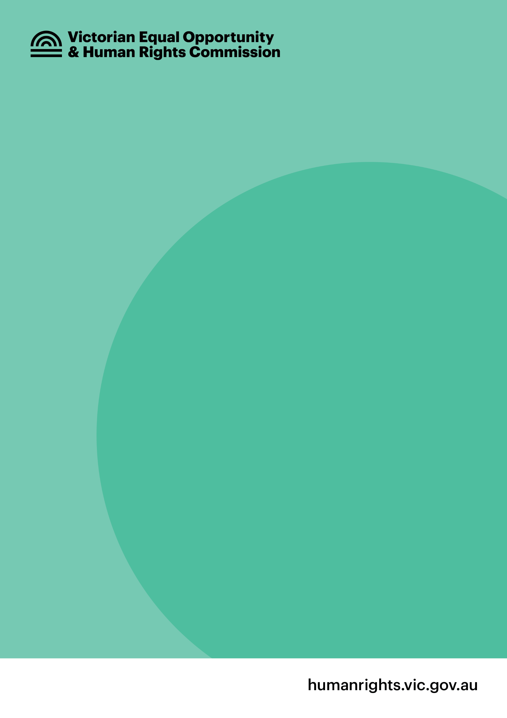
Enquiry Line 1300 292 153
Fax 1300 891 858
NRS Voice Relay 1300 555 727 then quote 1300 292 153
Interpreters 1300 152 494
Email enquiries@veohrc.vic.gov.au
Follow us on Twitter twitter.com/VEOHRC
Find us on Facebook facebook.com/VEOHRC

