
Human rights email banner
The human rights email banner is one way the Victorian public sector can promote the Charter of Human Rights and Responsibilities Act. It was created under the Charter Education Program, a whole of government initiative led by the Victorian Equal Opportunity and Human Rights Commission to build Victoria’s human rights culture.
Key messages
Purpose: The human rights email banner is designed to help the Victorian public sector visibly show commitment to the Charter and building a human rights culture in Victoria. Intended as default email footer, the banner provides a simple but powerful statement on keeping Victoria's Charter front of mind across the Victorian public sector.
Target audience: While anyone can attach the banner to their email, the target audiences of the banner are VPS staff who have participated in a human rights education program and VPS colleagues with a commitment to the Charter.
Disclaimer: This email banner should only be used in line with your Department / agency email signature guidelines. Please check with your Department / agency for any in-house approvals that may be required.
Instructions for use
To attach the human rights email banner to an Outlook email:
- Click on ‘Signatures’ in your email headline
- Click on tab ‘Email Signature’
- Scroll down to your signature window
- Cut the banner from below and paste the banner into the signature window beneath your current signature block.
Banner colour and size
Please use full banner in size and full colour as shown.

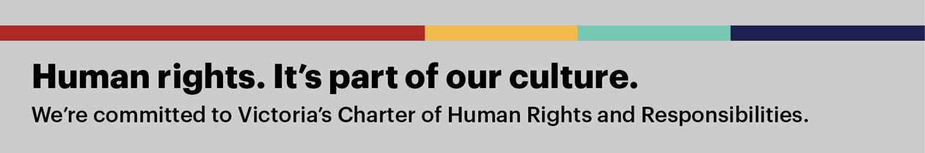

Contact us

For further information about the human rights email banner please contact the Charter Education Program at education@veohrc.vic.gov.au

